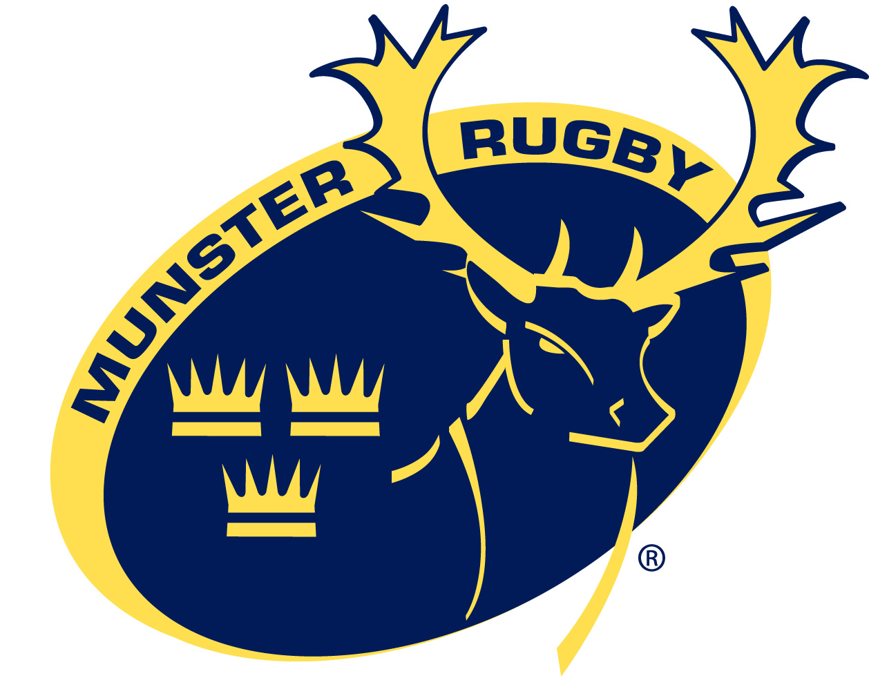

JOB DESCRIPTION & RESPONSIBILITY STATEMENT

1 POST TITLE:

First Team Physiotherapist

2 ROLE AND PURPOSE OF POSITION:

To provide physiotherapy services to the Munster Rugby First Team Squad and to deliver best practice sports medicine services in partnership with the Provincial Physiotherapist and Doctor(s).

To liaise and work with medical, fitness and coaching staff on all physiotherapy related issues within the Munster Squad.

3 REPORTING RELATIONSHIPS:

Operational: Lead Physiotherapist

Functional: Medical Director, Munster and Chief Executive, Munster

4 KEY QUALITIES:

Essential:
Degree or equivalent in physiotherapy / Registered with the Irish Society of Chartered Physiotherapists or equivalent.
A minimum of three years post graduate physiotherapy experience working in a clinical setting or sports medicine
Good communication skills.
Excellent interpersonal skills and the ability to develop credible and effective working relationships.
The ability to work well within a team environment
Good organisation skills and ability to manage own caseload.
Minimum of one year’s experience working as a physiotherapist in professional elite level sport.
Flexibility and willingness to work unsociable hours including weekends and evenings.

Desirable:
Postgraduate qualification in sports physiotherapy/musculoskeletal physiotherapy/sports science/Sports rehabilitation/Strength and conditioning.
Experience working as a physiotherapist working in professional/semi-professional rugby union.
Experience in planning and delivering individualised rehabilitation plans for both short and long term athletes.
Experience of working closely with other disciplines working within a high performance sport organisation such as strength and conditioning coaches, sport scientists, sports analysts, nutritionists, rehabilitation specialists and team management.
Pitch side traumatology qualification
Full clean Driving licence

4 RESPONSIBILITIES

To work with the Team doctor in the treatment and monitoring of injuries to Munster Squad injuries
Develop rehabilitation programs for long-term injured players
Assist with the local development and integration of the Injury Tracking/Monitoring system and ensure that the injury data is kept up to date
Assist in keeping accurate detailed records of all injuries (training and playing) including type of injuries, frequency of injuries and games missed.
Co-ordinate injury pre-habilitation and rehabilitation programmes of players
Work closely with other specialists and the IRFU fitness advisors especially in the pre-habilitation and injury rehabilitation of players
Take part in player education in consultation with team Doctor(s) and Fitness Staff on injury prevention, treatment and management
Assist in the completion of musculo-skeletal screening for all contracted players at the start of the season and implement individual pre-habilitation programmes as required. End of season screening should be completed where necessary.
Attend squad training and be available to give treatment at times suitable to you and the player. Ensure that there is a cross-cover arrangement in place for all absences, utilising the existing IRFU /Munster physiotherapy personnel
Provide match day physiotherapy and pitchside trauma cover for the Senior Team matches and training days and assist with ‘A’ games as required.
Complete written reports for coaching staff in preparation for squad training days. Communicate with coaches regarding progress of injured players on a regular basis.
Be trained and updated in acute pitch side care, including spinal injury, and cardiopulmonary resuscitation
Keep up to date on recent research in sports medicine and rugby related physiotherapy issues
Maintain and update your knowledge and practice of sports medicine, by participation in a proposed IRFU education program.
Assist the Head Physiotherapist with injury audit,

5 PERFORMANCE MEASURES

Develop and implement injury prevention protocols
Maintain satisfactory continued education in the practise of sports physiotherapy
Excellence in communication within the provincial medical, management and coaching groups
Ensure that the proposed Injury Monitoring database is kept up to date

This job description is not to be regarded as exclusive or exhaustive. It is intended as an outline indication of the areas of activity and will be amended in the light of changing needs of the organisation.

